SVN Command Prompt CC

Eclipse structure-

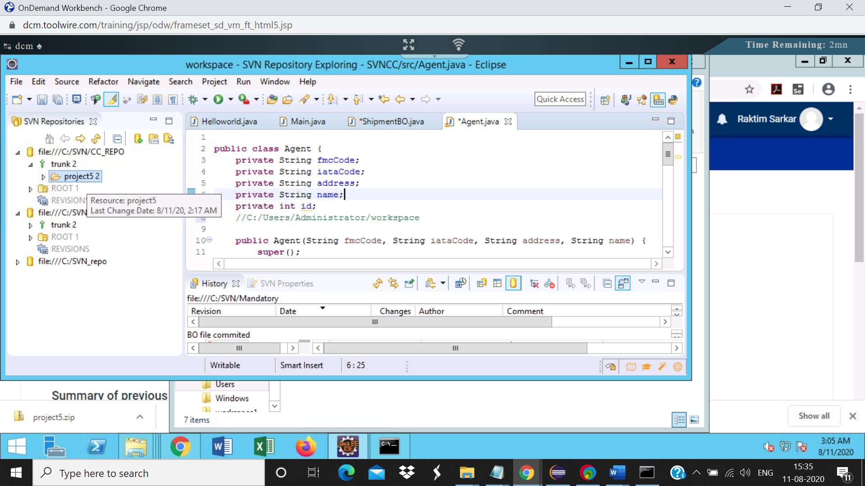

Step5: Check the status of the project.

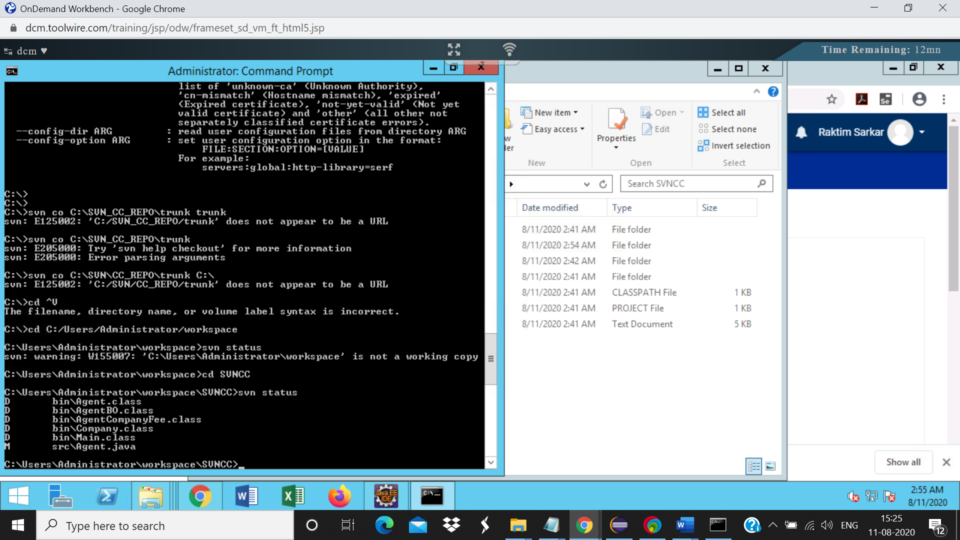

Step 6: Svn diff

|  |  |
| --- | --- |
| Get the diff for the Agent.java file |  |

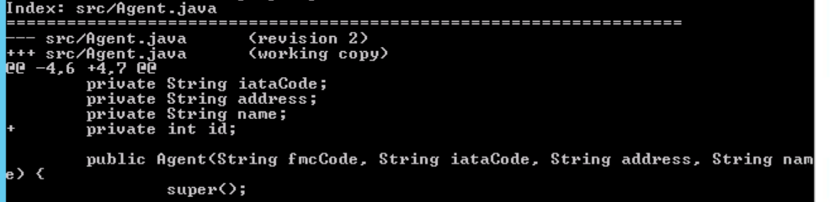

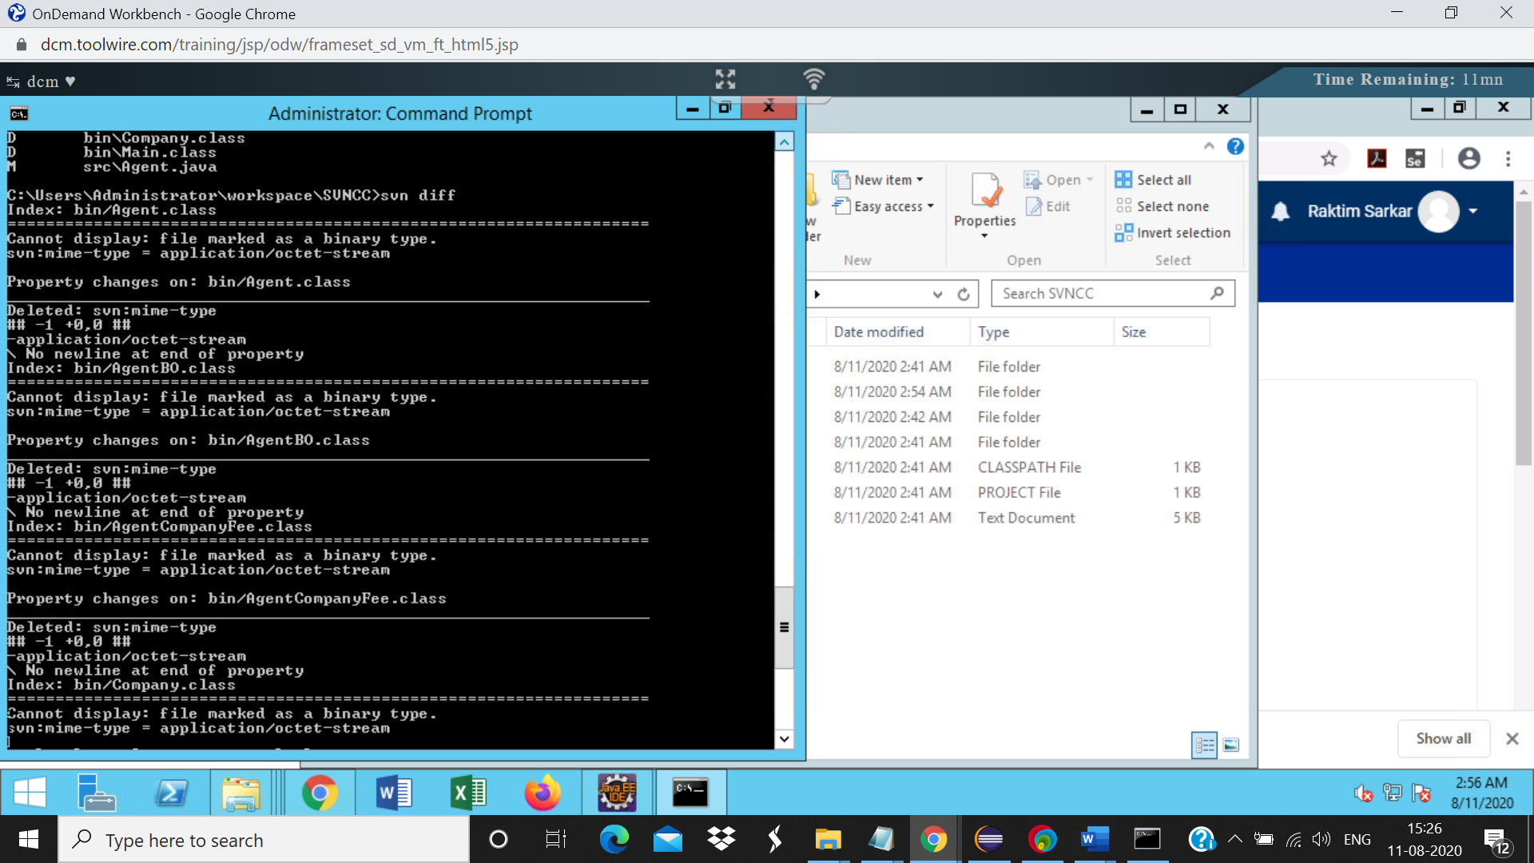

Step7: Svn commit-

